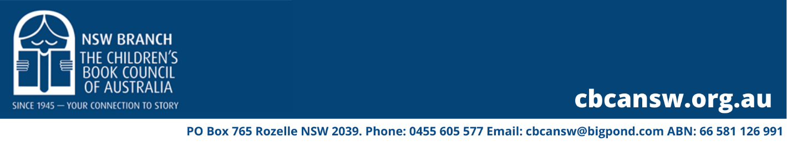

2022 Aspiring Writers Mentorship Program

Prepare ONE document,
as a Microsoft Word/PDF document, 12point Times New Roman.

Please do not enter your name or contact details on this page.

Manuscript Title:

Genre:

Target Age:

Pitch (50 – 100 words):

Blurb (30-100 words):

Writing experience (1-2 paragraphs):

Synopsis (for middle grade and YA, no more than 750 words):

