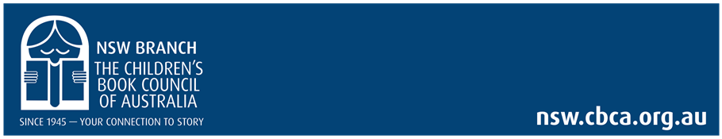
2020 CBCA NSW Branch Annual Report

Liz Bowring President
In the spirit of reconciliation, CBCA NSW Branch acknowledges the Traditional custodians of country throughout Australia and their connections to land, sea and community. We pay our respects to their elders past, present and emerging, and extend that respect to all Aboriginal and Torres Strait islander people today. We acknowledge their culture of storytelling and honour this tradition through the work of CBCA NSW Branch.
At the beginning of 2020 we were ‘consumed‘ by bushfires, that voracious environmental element which had destroyed so many homes, ecosystems and animals and kindled fear in the minds of so many children and adults. We had no idea of what was coming…
2020 has been a year of adaptability for CBCA NSW Branch, and I’m proud to say, with the assistance of our members, 2020 ended up being a stellar year for us. Not only did we move our regular program of events online, we created a whole additional range with a focus on connecting children with our author/ illustrator members. Collide!, Lunchtime Storytime, Curious Creatures Wild Minds at the Zoo and Story Scoop! All online for young people and their parents and teachers in lockdown.
These added to Kids Corner, AAA, Preparing for NAIDOC Week, Kids Book of the Year award event, Early Childhood quarterly newsletter and special author PD events comprised a rich offering. The year was bookended with members celebrating at live events – Night of the Notables and Aspire: High Tea with our Stars and the Lady Cutler Award.
We were fortunate that we had moved to control our website directly in 2019. While that year was a transition year with a few hiccups, in 2020 Felicity demonstrated her expanding skill set and has produced an impressive, attractive and resource filled website which reflects our purpose. The interactivity and the use of password protected video has enabled us to launch into production of high-quality online events with confidence. We are able to offer a section as a special member only benefit.
We were also fortunate that we had been using Zoom in 2019 to allow all committee members to attend meetings. Our account was expanded quickly and subbranches were using the account to involve members far and wide. The beauty of Zoom recording proved an asset in creating video for events.
Underlying our public face of activities was a substantial effort to address the ongoing discord between the branches and the National body. As no satisfactory forward plan by CBCA Board had been accepted by the Branches the challenge had then been laid by the board for the Branch Presidents to come up with an alternative. Planning involving the Branch Presidents and some past presidents continued throughout 2020, culminating in a Special General Meeting in October. Sadly, despite many requests for changes to be made within the remit of the existing Board, the Branch Presidents felt they had received little serious consideration of the pressing issues until this SGM.
The result has been a new Board, led by Wendy Rapee, and the requested move to more openness and responsiveness to Branch concerns is being met now, be it with a few hiccups along the way. I thank Megan Lavender, who stepped aside to allow Wendy to become our Branch Director. Also, thanks to Margo Hillel and other Directors who had to step aside as part of the process. We acknowledge and appreciate the work you all contributed.
Early in 2020 our Patron Megan Mitchell National Children’s Commissioner vacated her role. CBCA NSW Branch was excited to receive vice regal Patronage from our Governor of NSW, the Honourable Margaret Beazley AC QC and her husband Mr Dennis Wilson.
During July the Department of Education commenced a review of NESA and its accredited courses. The impact on us was limited in 2020, as we applied for and received special accreditation to run the AAA online in November. This will be an issue for us into the future as we wait for the new policy to be released.
Again in 2020 we experienced a significant decline in payment of membership fees. For 2021, the our planning must address the reasons for this. Are we aligned to member needs? Do people see the need to be a member? Is our billing process effective? Further questions to consider are: are we aligned to the purpose of CBCA? and how do we ensure we have the capacity to provide the program that members want?
I wish to thank all the CBCA NSW Branch Committee for their generous contribution of time and skills. In all of the following, the support in the of office Felicity Jagavkar, Business and events manager, has been instrumental in supporting committee, promoting events, managing the website, negotiating with publishers, engaging speakers and ensuring there are quality video presentations and face to face events.
Our executive Gail, Sue, Wendy, Natalia and Toni. Everyone on the committee rallies at events and contributes amazingly during meetings.
I wish to thank Sarah Foster (vice President Jan-April) and Lucie Towers, who have resigned from the committee, for their contributions
Kids Corner Jackie, Terry (and Marion ex-committee, covers by guest illustrators, contacted hundreds of authors)
Early Childhood Quarterly Magazine Gail, Laurel
Collide! Sue, Judith, Gail, Toni (Tristan Bancks, Deb Abela and Nathan Luff as ambassadors and judges)
Curious Creatures Wild Minds at the Zoo Wendy, Gail grant from the Copyright Agency Cultural Fund and Taronga Zoo education
Kids Book of the Year award event Gail
Night of the Notables Laurel and the committee
AAA: The information text in the Digital Age Gail, Laurel, Liz
Aspire: High Tea with our Stars and the Lady Cutler Award. Libby Hathorn is our Lady Cutler recipient for 2020 -21 Cathy and Liz and Denise
Special author PD with Emily Rodda, Anna Fineberg and Wendy Bannister Gail and others.
Contemporary Indigenous voices: Preparing for NAIDOC Week Liz and others
Lunchtime Storytime, members Victoria Mackinlay, Katrina McKelvey, Gemma Patience, Bronwyn Birdsall Social media 49 episodes
Story Scoop! In association with SCWIB
iRead contributions Peter
Also want to thank our wonderful Sub-branches who offer fabulous programs and reach out at a grassroots level. I’ve enjoyed the Zoom opportunity to meet with you as often as possible. Find the Sub-branch Presidents reports pp11-21.
Together we achieve wonderful things.
2020 Committee
Executive Committee:
President: Liz Bowring Treasurer: Natalia Bragaru
Vice President: Wendy Rapee Secretary: Sue Bates
Past President: Gail Erskine Public Officer: Toni Field
CBCA National Board Director: Megan Lavender * Wendy Rapee
Committee Members: Cathy Drury, Denise Cramsie, Jackie Hawkes, Judith Radin, Laurel Reynolds, Terry Fahy, Peter Macinnis
*Megan Lavender stepped down on the 26th October and Wendy Rapee took the position prior to a Special General Meeting of CBCA committee members on October 29th. We thanked for Megan for her service and contribution to the CBCA NSW Branch. Megan has taken on a position on the group of Responsible Persons overseeing the Awards Foundation CBCA.
NSW Judges 2020: Wendy Banister Early Childhood Category
Office Volunteers: Nigel Van Reyk and Li Gin (Thank you for your generous contributions)
Social media: Bronwyn Birdsall
CBCA NSW Branch Committee had embraced Zoom technology prior to the lockdown. This has facilitated members who live far from Rozelle such as the South Coast and at the foot of the mountains. Provision of a Zoom account to be shared by our members for meetings has enabled us to continue, and to engage with members all over the state as well as nationally and internationally. We maintain an office in the Writing NSW Rozelle precinct. Zoom does not replace getting together for a catch up, and we had a great Christmas dinner together for our December meeting. Committee members are always at events assisting the coordinator and ensuring everyone is welcome. Please consider volunteering as part of the committee. We also welcome assistance in the office and for individual events.
I would also like to acknowledge the continued support of publishers, authors and illustrators and our bookshop members. They ensure that we can offer the varied and exciting programs created by our volunteers of CBCA NSW Branch with the skilled support of our Business Manager Felicity Jagavkar.

Activities
February:
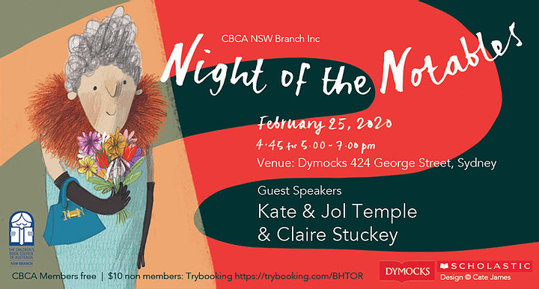
The Night of the Notables was held for the fifth time in collaboration with Dymocks, Sydney and sponsored by Scholastic. The night has increased in popularity over the years and the book shop was busting to bursting with excited book lovers.
Kate and Jol Temple and Claire Stuckey were our guest speakers.
As always there is great excitement as the Notable books were revealed and authors and illustrators were thrilled to be included on the list.
Coordinator: Laurel Reynolds, committee at venue

March:
It was the AAA Professional Development Conference which was the first to be impacted by the lockdown. We moved swiftly, anticipating that delegates would not be able to attend in person. We knew we needed to move the conference, but that the Professional Picks and the CBCA Shortlist needed to go ahead. So, this became our first online offering. Five volunteers read and presented their picks of the outstanding books published in the previous year. Fabulous titles were chosen and justified by Margaret Hamilton AM, Tristan Bancks, Olivia Flynn, Luke McMaster and Rachel McIntosh.
The advantage of online presentations is that they can be hosted on our website. Members have access to these videos.
The National CBCA produced a video of the Shortlist announcement shared on CBCA website. It was a novel experience and fun to watch.

The challenge was then to work out when we would be able to hold the remainder of our strong AAA program.
Eventually we were able to offer the conference online from November. With an innovative online trade fair, this conference retained its high rating with teachers.
Keynote Speakers:
Prof Lisa Harvey-Smith, Claire Saxby, Pamela Freeman & Liz Anelli , Lee Constable , Pauline Fitzgerald , Aunty Fay Muir,
Maryann Ballantyne
Louise Park
Dr Anita Collins
Sami Bayly
Katrina Nannestad
Lucy Bell
Jan Latta
Peter Macinnis

April:
AGM was held online.
May and June:
We are always open to new ideas and this was a great one. A group of members, led by Victoria Mackinlay proposed Lunchtime, Story Time, a live opportunity for a creative to connect directly with their audience - kids who were at home during the lockdown. Many hours of behind-the-scenes time was dedicated by Victoria and Katrina McKelvey gathering authors and illustrators to go online and troubleshooting problems for novice performers. Promoted by terrific illustration and design by Gemma Patience, and a daily social media campaign by Bronwyn Birdsall, this initiative resulted in 49 Lunchtime Storytimes which ran for the entire 10 weeks of Term 2. ‘Over 55,000 minutes was watched. That's more than 38 continuous days of viewing without pausing to eat or sleep’ The feedback was overwhelmingly excellent from all ages.
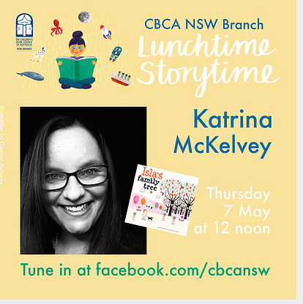

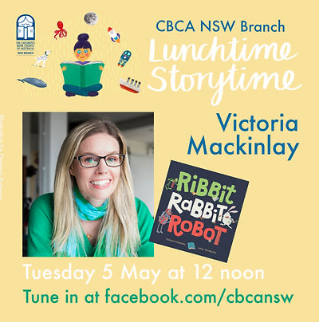
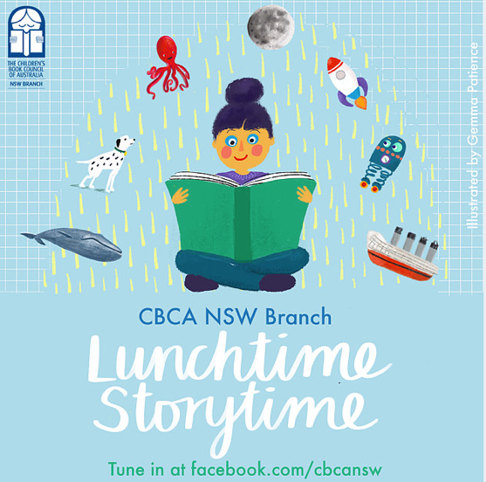

July:

Another brilliant idea was to get children to create a book trailer to promote a book, preferably a CBCA Shortlist book. Collide! Book Trailer competition was born and schools started creating their entries. With three author judge/ambassadors Nathan Luff, Deborah Abela and Tristan Bancks. Awards were announced at the Kids Book of the Year award ceremony. The winning trailers are available to view on the website.
Cordinators: Sue Bates, Judith Radin, Gail Erskine, Toni Field

August:

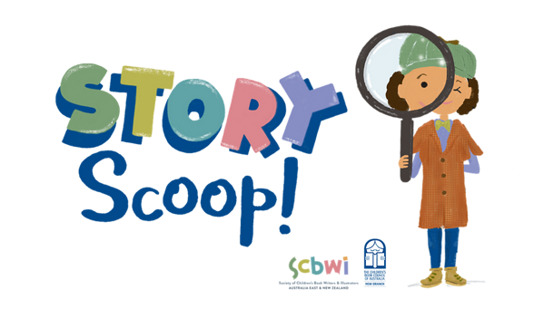
An ongoing collaboration between CBCA NSW Branch and SCBWI Australia East & New Zealand, commenced on the first of August. Continuing on the first of each month, released at noon, Story Scoop! presents short videos of authors and illustrators with new work. I have been amazed by the ingenuity and freshness of these videos which give an insight into their inspiration, creative choices, artwork and the story behind their stories. Featuring three segments including: Illustrators Corner, Picture Book Nook, Junior Fiction Gems, Middle Grade Magic and Sneak Peek,

Occasionally we have offers from publishers giving CBCA NSW Branch special access to authors and illustrators. In August, courtesy of Allen & Unwin, we held a Teacher & Librarian Online PD Event with two of Australia’s most successful and loved children’s authors, Anna Fienberg and Emily Rodda who were joined by Wendy Bannister, CBCA NSW Book of the Year Judge in the Early Childhood category. We even had an online bookshop, Better Read Kids.

‘Thank you and the CBCA NSW Branch for organising such an enlightening and stimulating event which I enjoyed in the comfort of my lounge room! I found both Emily Rodda and Anna Fienberg’s talks highly engaging with lots of thoughtful considerations to this year’s theme and an insight into their own creative minds. The fact that they were so different in the nature of what they wanted to share, I found I have invaluable information to pass onto my Year 7s.’ Anne G

September:

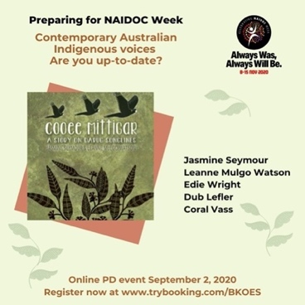
We celebrated our outstanding Indigenous Australian creatives with a special online presentation. Initially conceived to assist preparations for NAIDOC Week by showcasing contemporary Indigenous Australian Voices, the absence of NAIDOC Week from July meant moving our event as well.
CBCA shortlisted Dharug women Jasmine Seymour and Leanne Mulgo Watson were joined by educator and Bardi woman Edie Wright. Dub Leffler, of Bigambul descent & Coral Vass gave an extra-special reading of Sorry Day which could be shared with with students after the event.

Coordinators: Liz Bowring, Gail Erskine.

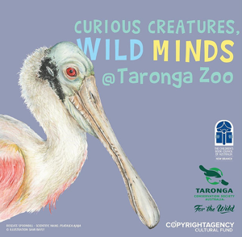
Curious Creatures, Wild Minds at Taronga Zoo
We were challenged to Leave the ordinary behind and become Curious and Wild last Spring when our Curious Creatives visited Taronga Zoo Sydney, thanks to a grant gratefully received from Copyright Agency’s Cultural Fund and with support from Taronga Education. Sami Baily, Lesley Gibbs, Abbie Mitchell, Charmaine Ledden-Lewis, Sue Whiting and Liz Anelli spent a day with a zoo-keeper and were filmed talking about or drawing their response to an up-close experience with a curious creature. The videos were released on Tuesdays and Thursdays over 3 weeks.

October:
Kids Book of the Year Event @ Taronga Zoo
​
This event was a unique opportunity for students and adults to celebrate the annual CBCA Book of the Year Awards online at the Zoo in the desert environment room live with Will Kostakis and our Curious Creatures, Wild Minds creatives live and pre-recorded student reviewers and Emily Rodda. It was an exciting experience which ran into the National recorded announcement of the CBCA Book of the Year Awards (Friday October 16).
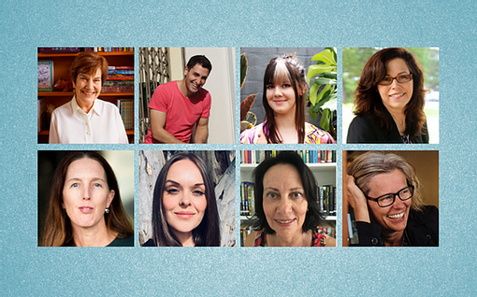
Both Zoo events were coordinated by Wendy Rapee and Gail Erskine, and a special mention needs to be acknowledged of the extensive contribution of Felicity Jagavkar in managing each day with liaison with the Zoo.

November:
Aspire & Celebrate! with our High Tea with the Stars and presentation of the Lady Cutler Award to Libby Hathorn was held at a face to face on Saturday 21 November. The vibe in the room was so positive and we all had a great time!
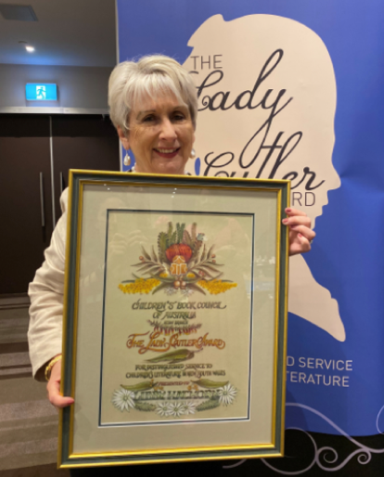
Aspire & Celebrate! with our Lady Cutler Award winner and High Tea Stars was held at Rydges World Square on 21 November. It was wonderful to be able celebrate with Libby Hathorn who was our Lady Cutler award winner for 2020.
Dr Kate Forsyth and Belinda Murrell launched their new book 'Searching for Charlotte: The Fascinating Story of Australia's First Children's Author'. Everyone in the room was caught up with their enthusiasm for the book and the book shop sold out of all of their copies of the book on the day.
After the formalities were completed and the delicious afternoon tea eaten we had our ‘stars’ who were emerging and established CBCA NSW Branch member authors/illustrators talk to us about their latest books.
They were: Nat Amoore, Liz Anelli, Sonia Bestulic, Jess Black, Marjorie Crosby-Fairall, Elizabeth Cummings, Susanne Gervay, Peter Macinnis, Victoria Mackinlay, Amelia McInerney, Louise Park, Katrina McKelvey and Julie Thorndyke.
The afternoon was special as it was the first event that many people had attended in person since everything went online in March.
Megan Lavender now retired, received warm thanks for her years of service in the role of CBCA NSW Branch Director. Megan has agreed to become part of the group of responsible persons overseeing the Awards Foundation, and we are pleased she will be continuing her association with CBCA.
Coordinator Aspire & Celebrate! with our High Tea with the Stars: Cathy Drury
Coordinators The Lady Cutler Award: Denise Cramsie and Liz Bowring

Teacher’s notes in the Member’s Lounge

While much of our information is freely shared with the public, the resources on the Teacher’s lounge are a special benefit for members of CBCA NSW Branch and are password protected. There is a rich offering including:
- Early Childhood Term Newsletter This resource will assist Parents/Grandparents of young children, Early Childhood Centres, Family Day Carers and Early stage one classes.
- CBCA Book of the year Awards Judges presentations
- Videos from conference delegates
- Teaching support material

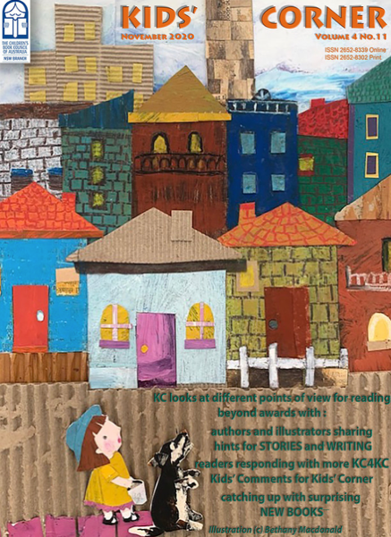
Kid’s Corner

Jackie Hawkes has continued to produce, in liaison with Terry Fahy and member Marion Silk, a monthly jam-packed edition of Kid’s Corner focusing on what’s happening the world of Australian children’s literature. This year each edition features a guest cover design by an established or aspiring illustrator.
Regular column from Ursula Dubosarsky, our Australian Children’s Laureate.
Cover by Beth Macdonald

iRead
continues as our monthly newsletter sent to members. Regular contributions are: an update from the President, news from the National Chair, information about CBCA NSW Branch and Sub-branch events as well as items of interest.
Our Facebook, twitter and Instagram pages keep us all up-to-the-moment thanks to the assistance of Bronwyn Birdsall and other members who contribute.
https://www.facebook.com/CBCANSW/ https://twitter.com/cbcansw https://www.instagram.com/cbcansw/
Membership
Membership has continued to decline since its peak in 2017. We have maintained a high level of member service, and have provided member benefits. Covid 19 will have been a contributing factor in 2020.

CBCA NSW Branch - Total Members
Year | Date | Total Members | School/Lib | Junior | Corp | Ben | A/I | A
2013 | 30/10/2013 | 687
2014 | 9/09/2014 | 691
2015 | 30/11/2015 | 687
2016 | 3/11/2016 | 645
2017 | 31/12/2017 | 714 | 320 | 3 | 24 | 30 | 141 | 196
2018 | 31/12/2018 | 702 | 307 | 2 | 23 | 30 | 148 | 192
2019 | 31/12/2019 | 710 | 317 | 0 | 26 | 30 | 159 | 178
2020 | 31/12/2020 | 674 | 317 | 0 | 25 | 30 | 143 | 159

Merchandise

Merchandise, although well received, was also a tricky proposition in 2020 as there were few face-to-face events and schools were closed down for many months due to COVID 19. The distributors were also closed for a long period and the change in date of CBCA Book Week was not observed by all clients. None of these factors would be expected to be relevant in 2021.
2020 Merchandise
Income
Merchandise | 13,712.48
Postage | 2,613.15
Total Income | 16,325.63
Expenses
Stock | 9,393.28
Postage | 2,196.67
Freight | 331.07
Total expenses | 11,921.02
Profit / Loss | 4,404.61

Sub-branch Reports

CBCA NSW Branch Blue Mountains Sub-branch President’s report
Welcome to our AGM as we come around to the conclusion of our sixth year of operations and promotion of children’s literature in the mountains - but what a year it has been!
In 2020, we were unable to conduct our normal activities due to Covid and the resulting restrictions. Initially, we thought we would be able to proceed with our usual Notables celebrations, however, the first restrictions came into place just in time to prevent this. We were delighted, however, that local authors, Amelia McInerney, Emily Rodda and Tohby Riddle were recognised on the Notables list for 2020.
Our Little Free Libraries (nine libraries) have had a quiet year as several have been packed away until Covid restrictions ease. Some proprietors, although totally supportive of the program, are reluctant to continue due to pressure of maintaining safe usage. We will have to rethink the placement and use of these. Thank you to Kristen, for keeping an eye on stock in the libraries that are still operational.
We had two very successful dinners at Le Petit Chalet where we enjoyed the hospitality and wonderful food of Monique and Roland. Our first dinner was held as Covid restrictions eased, with just the committee, but it was wonderful to do something ‘normal’ after a difficult year. We rounded the year off with a Xmas dinner, where we were delighted to have both Children’s Laureate, Ursula Dubosarsky and local author, Tohby Riddle. We enjoyed listening top Ursula’s discussion of her role as Laureate and Tohby providing background to Yahoo Creek, his shortlisted book of 2020. We look forward to their collaborative new book, The March of the Ants.
My thanks go to our hard-working committee, for staying around during this challenging year. Hopefully, conditions in 2021 will enable us to have some activities and normality and we can get on with the business of promoting children’s literature.
Looking forward to a safe year in 2021.
Sheryl Cootes, President

CBCA NSW Branch Central Coast Sub-branch President’s report
Our year started in the usual way with a bright planning meeting in February followed by our Annual General meeting in March which confirmed the new committee. I attended and spoke at the Night of the Notables in Sydney on the topic of Trends in Children’s Literature, with Kate & Jol Temple launching Bin Chickens. However, the Covid Virus soon caused changes to every aspect of our lives. Our committee put our plans for 2020 events on hold, cancelling our school visits by Gregg Driese which was fully booked out. Schools and other organisations had already placed restrictions on external visitors or events.
Our small committee was able to meet in person in a safe environment during the year so planning for our raffles and 2021 was possible. With beautiful donations from our local author/ illustrators Sara Acton and Dub Leffler members we were able to raise much needed funds. With safe venue for raffle sales provided by bookseller Bookface, Erina we also had an opportunity to promote the Children’s Book Council and our local branch.
A mini book launch took place for our local member Carly Taylor in October at Bookface to celebrate her first book Big Beach BBQ.
Our committee met in July, October, and December with planning for 2021 high on the agenda. We decided on a new format for our meetings that include “bring a book” and hope to invite more speakers. Our Christmas Dinner meeting included special guest Jackie Hawkes editor of Kids Corner. We have been promoting this fabulous resource all year to our local community and other relevant networks including the large Central Coast Home-school community. Online promotion of all CBCA events via our facebook page was the best way keep our presence during lockdown periods. Changes to the CBCA Board and improved communication between the NSW Executive and subbranches offer great positivity for 2021.
We are expecting further details for the Words on the Waves Festival scheduled for June where we also hope to promote the CBCA. In 2021 we anticipate that our successful events Shortlist Night and Pirate Day held in cooperation with the Central Coast Library will recommence.
With 2021 underway in a new meeting venue with Dub Leffler sharing his latest works in progress and his exciting international exhibition in the US our branch has already started the year on a happy note. The recent Notable Night Party was a fun and interesting evening as a small but Covid safe group watched the reveal and presentations in comfort at The Entrance Public School.
Building on a difficult and different 2020 our committee has shown resilience and tenacity in raising our profile in the community and raising our bank balance. A big thank you to all the executive and committee who have worked together to achieve our goals, goals that we can continue to achieve.
Claire Stuckey, President

CBCA NSW Branch Eastern Suburbs Sub-branch President’s report
A big thank you to all our hard-working volunteers for their work over the year. In particular, I’d like to acknowledge the committee members and acknowledge the work of Morag Tunks, our inaugural president without whom we would not be flourishing as a new sub-branch.
In 2020, we focused on:
Supporting our community:
In February we started our 2020 events with our AGM held at Waverley library in Bondi Junction and combined Zoom and face-to-face attendance to bring our event to as many of our members as possible. This AGM was followed by a dynamic and fascinating presentation by our secretary Jo Laretive who discussed visual literacy and her work with State Library NSW funded by the scholarship she received. Our meeting ended with a birthday celebration for Amanda Lieber and then dinner out at a local restaurant.
Little did we know that Zoom was to play a large part in our lives with the COVID pandemic’s ensuing social distancing restrictions and the rest of our meetings (April, June and October were held as Zoom events.) Highlights included Jules Faber’s books launch, Victoria Mackinlay’s launch, Deb Abela and Marjorie Crosby-Fairall’s Launch and hearing from Alison Evernden about how Speech Pathology Interventions work and how children's literature is used in that area of therapy.
We were so pleased to hold out December end-of-year Christmas party face-to-face with the loosening of restrictions and were able to continue our tradition of book donations for Sydney Children's Hospital Starlight Foundation as well as acknowledge special stars Susanne Gervay, Amanda Lieber and Elizabeth Hughes for their contribution to promoting our sub-branch and its endeavours.
Providing services:
With our ability to provide services to community impacted we were glad to be able to deliver bouquets of gratitude to our local bookshops on ‘Love Your Book Shop Day’ and Sue Mirow and I were met with great enthusiasm and gratitude in return by our local retailers who strived to support their customers during what was a most difficult time of lock down.
Fundraising:
Fundraising included profits from book launches (Jules Faber) online raffle and (Elizabeth Mary Cummings) October mini launch parties.
Spending funds:
This year was a year of thrift and the costs of the Christmas party were met by those attending paying directly to cover the catering costs.
Advocacy:
We maintained our relationships with libraries and bookshops by visiting these throughout the year.
Many thanks for all the support received from Liz Bowring our president and also from Felicity in our NSW Branch office. A particular note of gratitude to Wendy Fitzgerald who has not only provided guidance and encouragement to our emerging sub-branch but has attended every 2020 event and promoted these to her Northern Suburbs community. We would like to thank her and all who attended our events and kept our spirits up in the year of the pandemic.
Elizabeth Mary Cummings, President

CBCA NSW Branch Illawarra South Coast Sub-branch President’s report
Well, what a year we’ve had at CBCA Illawarra South Coast Sub Branch. I am happy to be able to report on a year of successful activities and opportunities to bring children, books, authors and illustrators together.

In 2020 we were successful in our pitch to secure a new Street Library for Wollongong via the national CBCA. One Street Library was available per state, and we won for NSW, on behalf of KU Gwynneville. The Street Library is located on Berkeley Rd in Gwynneville - the preschool decorated it and we donated children’s books for inclusion. Communities from the KU Gwynneville preschool, Gwynneville Public School and St Brigid’s Catholic Primary School are all benefitting from this new addition.

More than 1,000 students at our first virtual Book Week Literary Lunch held online in October 2020 - a ten-fold increase in attendance over previous years and a much wider geographical reach with students from as far away as Milton taking part. This workshop was led by author Nat Amoore, but also featured book updates from some of our talented local authors and illustrators, including Sue Whiting, Sam Squires, Kate Simpson, Karen Hendriks, Dale Newman and Di Ellis.

We’ve worked directly with Australian book publishers to source donated books, which we’ve then provided to people who need them. This included a donation of 50 books to Lake Conjola school students after the 2020 bushfires, and a donation of 100 books to MP Paul Scully’s 2020 Christmas book drive for people in need.

In 2020 we subsidised an author visit by Sue Whiting to St Therese Catholic Primary School, with 100 students taking part in the author visit. We’ve been fundraising with the aim of hosting more author visits to schools in future, as we know they have a positive impact on students.

At the CBCA Illawarra and South Coast Sub-Branch we believe it’s important to celebrate and support the talented local authors and illustrators in our city and region, and through this to inspire children with a love of reading and literacy. We’ve promoted authors and illustrators through promotion in the media including the Illawarra Mercury, Coal Coast magazine, ABC Illawarra radio and WIN TV, and have collaborated with the South Coast Writers’ Centre, to host story time sessions to complement their school holiday workshops.

In January 2021, we were named as a finalist for “Community Group of the Year” at the Wollongong City Council Australia Day Awards. Although we didn’t win, it was a wonderful opportunity to see examples of people in our community doing amazing things.

This year two of our long-standing committee members have decided to step down, and I’d like to thank Pam Crowe and Bob Crowe for all you have done to make the sub-branch such a successful organisation over the last two years, and Bob for holding the reigns as our Treasurer. Personally, I appreciate your easy-going natures and willingness to be involved – it’s been a pleasure getting to know you both.

As you can see it has been a busy year and it is worth remembering that our events are coordinated by a small group of very enthusiastic volunteers. For our great work to continue I would encourage you to put your name forward for a position. The work is not onerous, meetings are few and the contacts with local families, schools, authors and illustrators is a wonderful experience.

A huge thankyou to those who have supported us financially or by donating books this year: Officeworks Fairy Meadow (new banner), EK Books, Pan McMillan, Random House and CBCA NSW branch. Thank you to Corrimal RSL and Board member Paul Boultwood, who has provided our meeting space at no cost. Max Hamilton designed eye-catching posters and flyers for our events and the artwork for our new banner.

Finally, my thanks to all committee members for all you have done this year. You are a wonderful group to work with and I appreciate your ongoing support.

Kate O’Mealley
President

CBCA NSW Branch Newcastle Sub-branch President’s report
It goes without saying that 2020 was a year like no other! For our sub-branch it meant learning new tech skills, curtailing our outreach activities and for several months, hibernating at home. Yet despite this our members thrived; with new books released, awards received and many new online ventures.
We hosted five meetings throughout the year. Our March AGM was quickly reorganised to a Zoom platform. This was a first for most of us and was a trailblazer for CBCA NSW as well, who zoomed in to check us out. After discovering the importance of the mute button, the meeting ran surprisingly smoothly!
Our May meeting was again via Zoom. Local author Jess Black shared with us how she was adapting for online presentations, her latest series ‘Kitty is not a cat’ and her success with grants during this lean time.
We were thrilled to be able to meet face to face in July (with much distancing) and appreciated being hosted at Belmont Library. Kirrili Lonergan shared with us her and Lynn Jenkin’s new teacher resource kit for the Lessons of a Lac series. She then led us in an Art Therapy session. This was perfect relaxation after such a stressful few months.
We explored the CBCA Shortlist in our September meeting at Shortland Public School. Thank you to the CBCA members and those from Newcastle Libraries who prepared presentations. We particularly enjoyed meeting the engaging puppets produced by Newcastle Libraries for their Book Week play, modelled on the creatures from Sami Bayley’s shortlisted book, The Illustrated Encyclopaedia of Ugly Animals.
We concluded the year with our Christmas Party at West Leagues Club. For most of us it was the first group dining experience for the year, and we relished it! Our table was again lavishly decorated by our resident stylists Ruth and Kirrili. Thank you, ladies.
Our authors and illustrators may not have been able to engage in school visits, but they were certainly not idle during the year. A mad rush to master online engagement was the priority. Many of our members excelled at this. A huge congratulations to Liz Anelli, Katrina McKelvey, Jess Black and Sami Bayly who really mastered this medium.
Several our members took part in online initiatives developed by the CBCA NSW branch. Congratulations to Liz and Katrina for their professional presentations during Story Scoop, Nikki, Liz and Katrina for engaging us during Lunchtime Storytimes, and Liz and Sami for their entertaining glimpse of an illustrator at work in Curious Creatures Wild Minds @ Toronga Zoo.
Local Public Libraries, keen to engage audiences now working and studying from home, also involved our members. Congratulations to those chosen to read their books in Lake Mac’s first fore into online storytimes. Newcastle Libraries developed two workshop series with members Jess Black and Liz Anelli. Most of our authors and illustrators were interviewed for the Podcast series CHATS with fabulous children’s authors and illustrators and a number now have their stories available to be read by Pepper, the Digital Library’s humanoid robot.
2020 was an exciting year for many of our members with new titles released by Liz Anelli, Sami Bayly, Jess Black, Jenny Blackford, Jenni Goodman, Lynn Jenkins, Deb Kelly, Kirrili Lonergan, Nikki Bolton and Katrina McKelvey.
Many of our members also received honours and awards:
Sami Bayly, The Illustrated Encyclopaedia of Ugly Animals – CBCA Eve Pownell Honour Book, Winner Australian Book Industry Design Awards, Winner Children’s Indie Book of the Year Awards, Winner ABA Bookseller’s Choice Awards.
Jess Black, Mr Walker and the Dessert Delight, CBCA Notable Young Reader’s.
Jenny Blackford, The Girl in the Mirror – Winner Davitt Award, best children’s crime novel.
Deb Kelly, The Thing About Oliver – Winner Australian Therapists’ Award for Children’s Literature. CBCA shortlist Younger Readers, Shortlisted Speech Pathology Awards
Kirrili Lonergan – artwork displayed on the digital wall at the Bologna Book Fair.
We are also thrilled that two of our members are on this year’s CBCA Notable list. Fingers crossed Liz Anelli (2 books!) and Sami Bayly.
It was disappointing that we were not able to host a large community event. However hopefully our member’s online offerings have been encouraging and inspiring for children around Australia.
To promote our talented CBCA members our author and illustrator information booklet was completely revamped and provided to schools online at the end of the year. Thank you for your hard work in producing a useful and eye-catching booklet Lillian Webb.
Thank you to our enthusiastic and dedicated committee; Vice-President Lillian Webb for work with our Facebook page and our member’s booklet, Secretaries Kirrili and Katrina, for always have reports, news and minutes prepared on time, your encouragement and wisdom, Treasurer Amanda for your many years of prompt and accurate reporting, and to our committee members Ruth and Liz, for your support and encouragement during the year.
We have a great program planned for this year, and I look forward to being able to encourage our local authors and illustrators, promote them to schools and be involved in at least one community event where we again reach out to children.
Julie Swane, President

CBCA NSW Branch New England North West Sub-branch President’s report
It’s going to come as no surprise to anyone to say that 2020 presented great challenges. However, though plans had to be postponed and changed, we still managed to keep things going, not only collaborating again with the New England Writers’ Centre in the annual Booked In children’s literature program, but also to learn the delights of Zoom meetings through the period of shutdown and beyond. Once it was safe to do so, and restrictions had been lifted, we were able to return to the Armidale Library for our regular themed meetings. This year, themes of meetings (both those in person and online) included endpapers in picture books, the beach in children’s fiction, crime/ mystery for children and YA, and presentations by local illustrator Sandy Flett and local bookseller Michelle Wheatley. There was also the always-popular discussion of the CBCA shortlist, presented by former CBCA Awards judge and sub-branch member, Dr Heather Fisher.
As mentioned earlier, we collaborated again this year with the New England Writers’ Centre in the annual Booked In children’s literature festival. It was due to be held in May, as usual, but due to covid restrictions was postponed to October, and was then rolled out successfully. Our featured visiting author was multi-award-winning writer and Australian Children’s Laureate Ursula Dubosarsky, who visited schools in our immediate New England region – Armidale, Guyra, and Uralla, across a range of age groups and group sizes. Most of these sessions were in person, with a couple held via Zoom. She also gave a talk at local independent bookshop Reader’s Companion and presented an amazing workshop at the New England Regional Art Museum, around her book Leaf Stone Beetle, with the virtual collaboration of publisher Margrete Lamond, who co-presented from her home in Orange, as she was unable to come to Armidale as planned. Margrete was to also visit schools as part of Booked In, but was unable to do so, even online. So, wearing my hat as a local author, I stepped in to take over Margrete’s sessions, with NEWC picking up the bill for my fee, a supportive gesture which our sub-branch greatly appreciated. It was really good that as a result I was able to physically visit a number of small, rural/remote schools such as Kelly’s Plains and Rocky River, as well as a delightful rural pre-school at Bundarra.
We were also involved in publicising another initiative by the New England Writers’ Centre in 2020, the By the Book video series, which showcases the literary creative talent and professional expertise in our region, and features several children’s authors, illustrators and publishers, as well as writers and illustrators creating for adults. You can see the video series playlist here: hSps:// www.youtube.com/playlist?list=PLIbxtluPDMyOfD9utPmyoXuwlOhDhRh39
Once again, we participated in publicity and promotion around NEWC’s very successful national award for illustrators, the New England Illustration Prize, which in 2020 was in its fifth year.
Our finances and administration are in great shape as ever, thanks to our Treasurer Lyndal Knuckey and Secretary Sylvia Ransom, and we look forward to a new year full of great activities, including Booked In, which we will again collaborate on with the Writers’ Centre and which will feature school visits, a bookshop talk and a community workshop in Armidale and district by popular author- illustrator Gabrielle Wang, as well as presentations by local illustrator Sandy FleS. Taking any potential covid-restriction issues but also school preferences into account (local schools frequently mentioned ‘screen fatigue’), we have planned for the 2021 Booked In program to be presented in person if possible, but with the possibility of being moved to online if necessary.
Sophie Masson AM, President

CBCA NSW Branch Northern Sydney Sub-branch President’s report
Our main activities for our last financial year were as follows
Meetings
6th Feb- We had a committee planning meeting at President Jan Latta’s house to organise and steer major events.
8th April – Event 1- AGM on zoom.
21st May- Zoom committee meeting
24th June- Event 2- Zoom with Deb Abela and Marjorie Crosby-Fairall talking about their book ‘Bear in Space’ Paul MacDonald spoke.
29th July- Event 3- Zoom- Jan Latta interviewed Alice Achan and Philippa Tyndale – ‘The School of Restoration’
9th September- Event 4 – Zoom- Ursula Dubosarsky interviewed by Kristin Darell. Book launch of Oliver Phommavanh’s book- Brain Freeze.
25th November- Event 5- Xmas zoom. Publishing panel- Q & A with Louise Park interviewing Eva Mills (Allen and Unwin) and Alexandra Yatomi-Clark (Berbay Publishing) from Melbourne. Belinda Murrell and Kate Forsyth spoke about ‘Searching for Charlotte’ and Jean Saxby launched Amy Adeney’s books. We had a Xmas Quiz and Wendy Blaxland performed an original Xmas poem. There were prizes for the quiz and for best zoom decoration.
Due to Covid these events were cancelled
8th April- Event 1 and AGM- at Grace Cossington Smith Gallery – exhibition ‘Visualising Stories’ featuring children’s illustrators- Liz Anelli, Lorena Carrington, Tannya Harricks, Beth McDonald and Aura Parker.
24th June- Event 2 – Deb Abela and Marjorie Crosby-Fairall at Paul MacDonald’s Bookshop in Glebe.
29th July- Xmas in July at Forestville RSL- Debate planned by Oliver- who is more important- author or illustrator?
15th September- Lunch with the Stars at St Pats in Manly. Guest speakers- Louise Park and Susannah McFarlane and 18 other authors and illustrators, kids and teachers.
25th November- Casual Xmas Drinks at Terrey Hills Tavern.
We continued our segment called Book Babies/ member news, where members introduce their newly published books and tell their news to the audience. This proves to be a popular segment.

We had no Author afternoon teas in schools due to Covid restrictions.

Warringah Library Services Young Writer’s Competition. In August, some of our members were again invited to be judges in this writing competition. It involved judging stories and presenting prizes at a special presentation night at Glen Street Theatre. The presentation was streamed and there were no kids in attendance. Louise Park, Oliver Phommavanh and Wendy Fitzgerald were 3 of the judges. (Lindy Batchelor started this competition 8 or 9 years ago.)

Travelling Suitcases. Ashling Kwok and Teresa Souter looked after the suitcases, but they are in isolation due to Covid. We have 5 travelling suitcases. Oliver Phommavanh, Belinda Murrell, Louise Park, Jan Latta and Kate Forsyth.

Donations and Grants- We received $474 from CBCA NSW in memberships.

Plans for 2021 Hopefully we will be able to host events again in 2021. Our aim remains to help inspire children, librarians and parents with enthusiasm for books and reading. We have some terrific things planned for 2021.

These events happen because of the generosity, good will, creativity and hard work of our committee members. Thank you to all the 2020 committee-

Co-Presidents- Jan Latta and Wendy Fitzgerald
Vice President- Matthew Shalvey
Secretary- Debra Tidball
Treasurer- Louise Park
Minutes Secretary- Jean Saxby
Lunch with the Stars- Jan Latta and Wendy Fitzgerald
Graphic Designer- Jan Latta
Travelling Suitcases- Ashling Kwok and Teresa Souter
Other Valuable Committee Members- Marian McGuinness, Wendy Blaxland, Kirsty O’Rourke, Oliver Phommavanh and Fran Jones.

We are delighted to be linked with Warringah Library Services and are very happy to help with their events. We thank Jan Latta and Wendy Fitzgerald for doing an outstanding job as co-presidents in 2020.
We appreciate and congratulate everyone in the CBCA NSW Branch Inc Northern Sydney Sub-branch for making all these terrific things happen in the community that link kids, books and authors.
We will continue to support CBCA NSW events as well- Night of Notables, AAA Event, AGM and High Tea with the Stars, BOTY event, Book week merchandise etc. We’d also like to thank the CBCA NSW Branch for their terrific events, inspiration, encouragement and support. And we thank them for providing a zoom platform for us to use so we could continue to ‘meet’ during Covid.

Jan Latta and Wendy Fitzgerald, Co-Presidents

